Team Number: 44
Project Title: Breast Cancer Stage Classification with miRNA
Report Date: 11/03/25
Part one: Progress status as a team
All team members have detailed tasks listed on Teams Planner: YES or NO; if NO, explain.
Yes
Please answer the following questions:
- Have you met as a team this past week? If yes, give date/time, and the members attended the meeting. If no, explain.

We did not hold formal team meetings. We coordinated daily through our team’s Discord server to discuss individual and overall progress, assign tasks or resolve questions/issues.

- Have you met with the sponsor as a team? If yes, give date/time, and the member attended the meeting. If no, explain.

No, we haven’t met with Dr. Ali Ibrahim as a team. Instead, we’ve been communicating with him by email, sharing our recent project deliverables for his feedback and guidance.

- Describe verbally the tasks completed the past week and the challenges faced.

During Weeks 12 through 14, we concentrated on turning the project poster into a clear one-page story of our entire work, since it is the main snapshot of our project and results for anyone viewing it. Most of the effort went into deciding what to show and how to show it, for example selecting which graphs and diagrams best communicate our methods and findings without overwhelming the reader. We prioritized sharing the completed poster with our sponsor, Dr. Ali Ibrahim, for feedback before submission.

In parallel, we prepared the Project Status Report slides for the second prototype demonstration and recorded the demo video, which was challenging because time was tight and since this is a research project we wanted to cover enough details so our methods and results could be clearly understood. We also finished organizing clean, stage-wise notebooks for each feature selection family (traditional, deep learning, and clustering) along with the corresponding folders and outputs, and uploaded all these deliverables to our Teams space so they can be easily accessed and reviewed.

- Describe the tasks to be completed the coming week.

We will focus on our Final Project Presentation and Demonstration, making sure the slides and demo clearly show what we originally planned to do, what we actually completed, and the main lessons we learned along the way. This will also help us get ready for the Senior Design Showcase demonstration. In parallel, we will start putting together the Final Project Report, using the outline and writing guidelines we were given. Each member will be responsible for drafting their own sections but we will also review and give feedback on each other’s writing and content so the report feels consistent.

Previous Report Summary. Date: 10/20/25
 | # Tasks completed past week | # Tasks not completed | # Tasks for next week
Joshua Adegboyo | 3 | 0 | 2
Anika Baro Villa | 5 | 0 | 3
Nicholas Campos | 3 | 0
Brehon Parker | 3 | 0 | 2

Current Report Summary. Date: 11/03/25
 | # Tasks completed past week | # Tasks not completed | # Tasks for next week
Joshua Adegboyo | 2 | 0 | 2
Anika Baro Villa | 3 | 0 | 2
Nicholas Campos
Brehon Parker | 2 | 0 | 2

Name of the Member: Joshua Adegboyo
Report Date: 11/03/25

Task 10.1: Apply Stage-Wise Traditional Feature Selection Using LASSO (10/25/25)
For this task, I implemented LASSO (Logistic Regression with L1 regularization) as my traditional feature-selection method. The procedure was performed stage by stage (Normal vs Stage I–IV) to identify the most influential miRNAs associated with each cancer stage. To maintain consistency with the deep-learning pipeline, each run followed by the same 70/30 train-test split, StandardScaler normalization, and class balancing approach. For each binary comparison, I trained multiple LASSO models across different C values and selected the best-performing one based on validation accuracy. Features were ranked according to the absolute coefficient magnitude of the best model. For every stage, I exported the Top 5, Top 10, and Top 15 miRNAs as separate CSV files alongside a full ranking file. These outputs will be used in the upcoming cross-method overlap analysis to compare traditional vs deep learning vs clustering results. Preliminary validation accuracies ranged between 0.61 and 0.67 across stages, confirming the method’s stability and reproducibility.
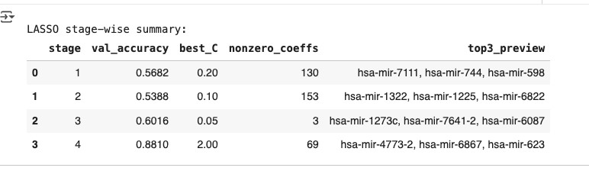

Task 10.2: Apply Stage-Wise Deep Learning Feature Selection Using LSTM (10/25/25)
As my deep-learning approach, I extended the stage-wise framework using a Long Short-Term Memory (LSTM) network. Each model compared Normal vs Stage I–IV samples separately, treating each miRNA as a sequential input feature. The LSTM architecture consisted of one LSTM layer (32 units), dense layers with ReLU activation, dropout for regularization, and an output sigmoid node for binary classification. Training used class-balanced weights and early stopping to prevent overfitting. After training, I calculated permutation importance scores for all miRNAs on the validation set to determine their impact on accuracy. For each stage, miRNAs were ranked by importance, and the Top 5, Top 10, and Top 15 miRNAs were exported as CSV files. Model validation accuracies ranged from approximately 0.58 to 0.64 across stages, indicating meaningful pattern recognition despite limited sample sizes. These results confirm that the LSTM method can identify stage-specific non-linear relationships among miRNAs that traditional statistical methods may overlook.
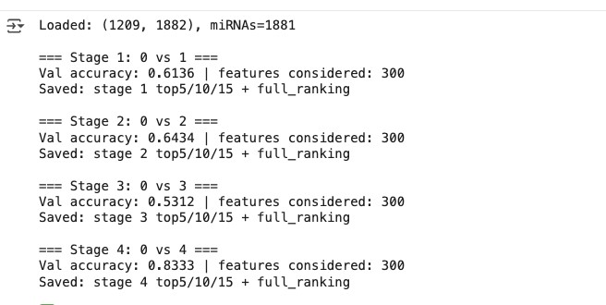

Task 10.3: Apply Stage-Wise Clustering as Feature Selection Using K-Means (10/25/25)
The final phase of my feature selection work will apply K-Means clustering to detect groups of miRNAs with similar expression patterns for each stage comparison (Normal vs Stage I–IV). Each analysis will produce two clusters per stage, then we will determine the important cluster which may be determined either by literature support or by selecting the smaller cluster based on variance.
All preprocessing steps (StandardScaler normalization and data transposition) will be identical to the previous tasks to maintain comparability across methods. Outputs will include a pair of CSV files per stage (representing the two clusters) to support the upcoming cross-method overlap analysis scheduled for completion before poster submission on Nov 3.

Task 11.1: Generate Stage-Wise Consensus miRNA Lists (11/05/25)
For this task, I will integrate the outputs from my three feature-selection pipelines; LASSO (Traditional), LSTM (Deep Learning), and K-Means (Clustering) to construct unified, stage-specific consensus miRNA lists.
For each stage comparison (Normal vs Stage I–IV), I will collect the Top 5, Top 10, and Top 15 miRNA lists produced by all three methods. Using these sets, I will identify overlapping or consistently recurring miRNAs across methods. The degree of overlap will be used to determine which miRNAs show cross-method agreement, reflecting biological robustness and computational consistency. These files will represent the most reliable stage-specific biomarkers, serving as the foundation for the next classification phase.

Task 11.2: Train and Evaluate Stage-Wise Classifiers (11/09/25)
Using the consensus miRNA lists from Task 11.1, I will perform stage-wise classification to assess the discriminative capability of the selected biomarkers. Each classifier will focus on differentiating Normal vs Stage I–IV, maintaining the same 70/30 train-test split used in earlier phases.
I will train multiple machine-learning models; K-Nearest Neighbors (KNN), Support Vector Machine (SVM), Random Forest (RF), and Logistic Regression (LR) to evaluate classification accuracy across methods. For each model and stage, I will compute key performance metrics, including accuracy, precision, recall, F1-score, and confusion matrices. The results will be summarized in both tabular and graphical formats to compare classifier effectiveness per stage and determine which consensus-derived feature set yields the highest predictive performance.

Task 13.1: Prepare Traditional & Deep Learning Results for Project Status Report and Demonstration (11/10/25)
I prepared the Traditional (LASSO) and Deep Learning (LSTM) stage-wise feature-selection outputs needed for our project status report and upcoming second demonstration. This included running and validating both pipelines (Normal vs. Stage I–IV) and confirming that each stage correctly generated the required Top-5, Top-10, and Top-15 miRNA lists. I reviewed and organized all generated files to ensure naming consistency and reproducibility before sharing them with the team. These outputs will be used in the Stage-Wise Consensus and Classification phases. I also began outlining my portion of the demo narrative explaining how traditional feature selection operates using LASSO and how the LSTM model determines miRNA importance in a stage-wise context.
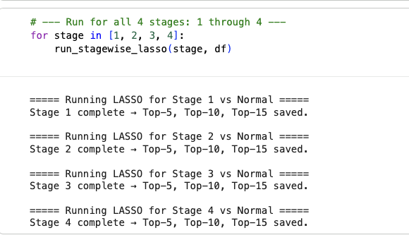
Task 14.1: Traditional Feature Selection Completion, Consensus Preparation, and Demo Development
Over this period, I completed the full stage-wise execution of the LASSO traditional feature-selection pipeline on the TCGA breast cancer dataset, generating the required Top-5, Top-10, and Top-15 miRNA lists for Stages I–IV. I validated all outputs for consistency, ensured correct formatting and naming conventions, and uploaded the finalized 12 traditional method files to the shared Teams directory. I then refined and organized these files to support the upcoming consensus analysis, confirming uniform miRNA naming, correct indexing, and alignment with outputs from the deep learning and clustering methods. In preparation for the team’s recorded demonstration, I also developed the narrative and technical walkthrough for the Traditional method segment, clearly explaining how LASSO identifies stage-specific miRNA importance and adding a coefficient-based visualization to enhance clarity and presentation quality.
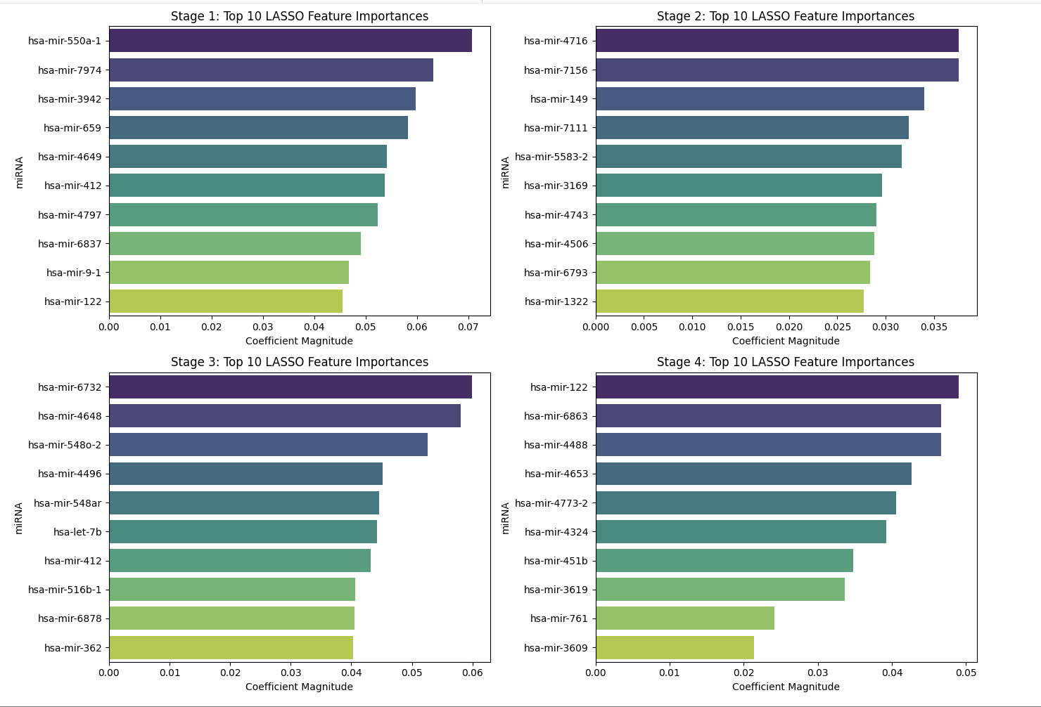

Task 15.1: Prepare Final Presentation Introduction and Requirements/Goals Sections (12/03/25)
As the group leader, I am responsible for delivering the opening portion of our final project presentation, including:
- The Introduction to the project
- The full Project Goals overview
- The Project Requirements and Constraints section
To prepare for this, I will consolidate all work completed throughout the semester; dataset acquisition, pipeline development, stage-wise feature selection across all three method families, consensus generation, and classification, into a cohesive narrative that frames our system architecture and the motivation behind our stage-wise approach.
Task 15.2: Prepare Final Presentation Demo Segment for Traditional Method (12/03/25)
Alongside the introduction and contribution to the presentation template, I will present the Traditional feature-selection demo in the final recorded video. This includes walking through the LASSO notebook, explaining preprocessing steps, demonstrating how stage-wise feature importance is extracted, and showing where the Top-k miRNA lists are generated and saved. This segment ensures that all three method families have a clear, standardized representation in the demo.

Name of the Member: Anika Baro Villa
Report Date: 11/03/25
Task 10.1: Apply stage-wise traditional feature selection using SFS (10/22/25)
Our dataset contains miRNA expression profiles from 2 types of samples per comparison: non-cancer control tissue (Normal) and tumor tissue labeled by clinical stage (I–IV). So in this task, I treated each stage as its own problem (Normal vs. Stage I, Normal vs. Stage II, and so on) so that the results would be directly comparable across stages under 1 fixed setup and label scheme. I standardized the features and trained a logistic-regression model, then used Sequential Feature Selection, which builds the set 1 feature at a time (starting from none, testing each candidate, keeping the best, and repeating) while scoring with five-fold cross-validated ROC-AUC to keep the ranking robust and repeatable. For every stage, I generated 3 subsets (Top-5, Top-10, Top-15) and saved them as CSV files for later comparison. Additionally, I printed accuracy and AUC as quick checks to document what the model saw, while keeping the actual selections strictly driven by the SFS procedure.
Task 10.2: Apply stage-wise deep learning feature selection using FNN (10/23/25)
Building directly on the SFS setup, I kept the same stage-wise framing (Normal vs. Stage I–IV) and fixed configuration so the deep-learning results are directly comparable. For each stage, I split the data with a smaller validation/test when the positive class is tiny, standardized features on the training set only, and computed balanced class weights. I then trained a small feed-forward neural network with 1 hidden layer (ReLU) plus dropout and L1+L2 regularization, optimized with Adam and early stopping to prevent overfitting. To stabilize the ranking, I repeated training across several fixed random seeds and, for each run, extracted per-miRNA importance from the first dense layer by summing the absolute input-to-hidden weights; I averaged these importances across seeds and sorted the features. For every stage, I saved the full ranking to CSV and exported 3 subsets (Top-5, Top-10, Top-15) for downstream comparison; accuracy and AUC were printed as sanity checks only, since selection is weight-based.
Task 10.3: Apply stage-wise clustering as feature selection using K-Means (10/24/25)
I kept the same stage-wise framing used earlier, treating each comparison separately as Normal versus Stage I, II, III, and IV so results are directly comparable. For each pairing, I filtered the data to those 2 labels, separated expression from labels, transposed into miRNA by samples, and standardized before clustering. I then ran K-Means with 2 clusters and recorded the silhouette score and cluster sizes to document separation quality. After fitting, I saved the miRNA membership for each cluster to CSV files and produced a simple PCA plot to visualize the 2 clusters in the first 2 principal components. Finally, I summarized each stage’s silhouette and cluster counts in a small table to support downstream selection and overlap work.
Task 11.1: Generate stage-wise consensus miRNA lists per feature-selection approach (10/30/25)
For this task, I combined the outputs from all individual feature-selection methods to generate unified, stage-specific consensus miRNA lists for each family (traditional, DL, and clustering). Before running the consensus script, I validated that all expected input files were present, correctly formatted, and contained no missing or duplicate entries. Using these verified files, I built frequency tables showing how often each miRNA was selected across the 4 methods in its family and then computed 3 consensus sets per stage and k: intersection (miRNAs selected by all 4 methods), majority (selected by ≥ 2 methods), and union (selected by any method). I saved these consensus lists for each stage and approach, along with summary tables detailing the number of methods contributing to each set.
Task 11.2: Train and evaluate stage-wise classifiers (10/30/25)
For each stage (Normal vs. Stage I-IV), I used the consensus miRNA lists generated and used them as input features to train 4 classifiers: Logistic Regression, linear SVM, Random Forest, and KNN. I run all models on a consistent train/test split per stage, with scaling handled inside the pipeline and class weights turned on for imbalance. For every (stage, feature set, classifier) combination I recorded accuracy, sensitivity, specificity, and AUC, and saved all results to a csv file. As expected, Stages I-III produced meaningful signal, while Stage IV remained unstable because it only has 15 breast cancer samples total.
Task 12.1: Prepare project poster for Senior Design Showcase (11/03/25)
I drafted the content of our project poster for the Senior Design Showcase. I created the header; wrote the Problem Statement, Results, and Conclusions and Impact sections; designed the workflow diagram to clearly show our stage-wise approach and key outcomes; and added the main graphs (dataset distribution by stage and the best balanced classification results across our methods). I also made sure the tone and formatting were consistent so the poster presented our stage-wise classification system and findings as one coherent story. Before submitting, I sent the draft poster to our sponsor Dr. Ali Ibrahim for feedback.
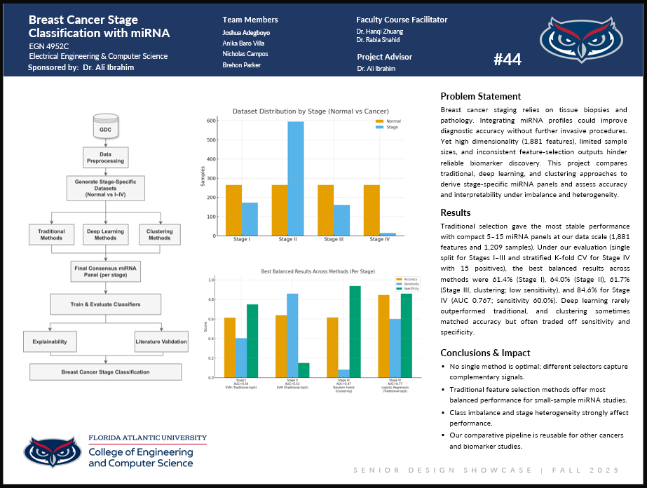
Task 13.1: Prepare project status report slides for second demonstration (11/10/25)
I completed the project status report slides for our second demonstration, summarizing our project’s current status and completed work. The slides highlight key milestones: dataset acquisition and cleaning, linkage of clinical stage labels, and stage-wise feature selection across traditional, deep learning, and clustering approaches. It also includes the stage specific consensus miRNA panels, completion of stage-wise classification using these panels, and cross-method interpretations per stage. I produced the first full draft to ensure consistency across the entire slide deck and shared it with the team for review. The following screenshot shows one of the slides just for reference.
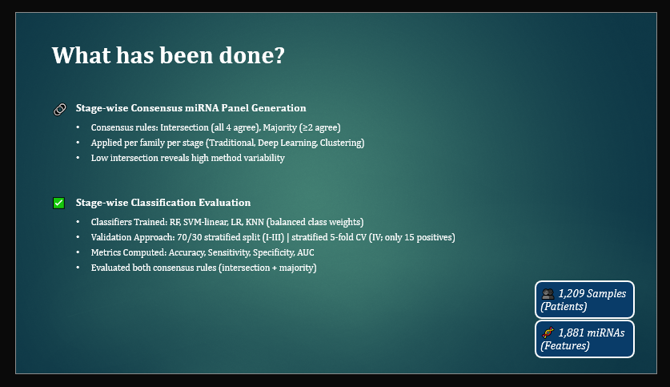
Task 14.1: Package stage-wise notebooks for traditional, deep learning, and clustering feature selection (11/17/25)
I cleaned and packaged the 3 stage wise notebooks for our breast cancer miRNA classification pipeline (Normal vs. Stage I through IV), one per feature selection family: traditional, deep learning, and clustering. By putting all methods from the same family into a single notebook, I made sure they share the same preprocessing steps, parameter settings, fixed random states for reproducibility, and consistent output filenames. I uploaded all 3 notebooks and their output folders to our Teams space alongside the existing consensus and classification deliverables, and shared them with our sponsor, Dr. Ali Ibrahim, for his review and feedback.
In the traditional notebook, I run SFS, Variance Threshold, Chi-square, and LASSO to automatically generate Top-5, Top-10, and Top-15 miRNA lists per stage; the deep learning notebook implements FNN, DAE, 1D-CNN, and LSTM with five-fold cross-validation and also produces Top-5, Top-10, and Top-15 miRNA lists per stage based on averaged first-layer weights; and the clustering notebook applies K-Means, Spectral, GMM, and Hierarchical methods with a documented rule to select the “important” cluster for each stage. In total, these notebooks export 112 CSV files to our TeamsExports folder. The following screenshot shows a code snippet from the traditional methods notebook, showing the automated stage-wise loop that generates the Top-5, Top-10, and Top-15 miRNA lists for each feature selection method.
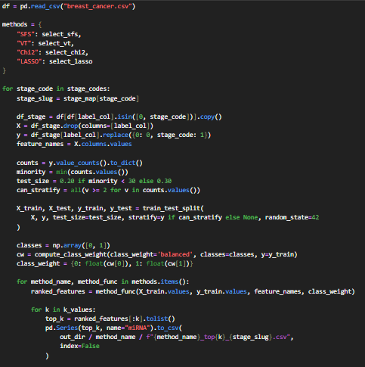
Task 15.1: Prepare final project presentation and demonstration (12/03/25)
For this task, we will put together our final project presentation and demo covering our project goals, requirements and constraints, design, implementation, testing, and a short demo. I will be mainly responsible for the Project Implementation and Testing sections, walking through how we actually built the stage-wise miRNA classification pipeline, but as always I will review the entire slide deck to help keep everything consistent.
Task 15.2: Prepare final project report (12/07/25)
For this task, I will contribute to setting up the final project report template so everyone can easily add their sections, and I will draft the Implementation Details section, including system specifications and functionalities, system and subsystem UML diagrams, and a summary of testing results.
Name of the Member: Nicholas Campos
Report Date: 11/03/25
List the following:
- All tasks completed the week before the past week (completion date in parenthesis). This is copied from the last report, and if this report is the first one, skip. Highlight these tasks in cyan.
- All tasks completed the past week (completion date in parenthesis) Highlight these tasks in green.
- Tasks you attempted but did not get to complete due to time constraints or other factors in the week. Highlight these tasks in red. (attempt date in parenthesis)
- All tasks you are currently working on (tasks that require more than 1 week) or planned for this coming week (expected completion date in parenthesis) Highlight these tasks in yellow
For each task you have completed during the past week: Avoid leaving filler or template text in your reports
- Task number/name
- Short description – these descriptions form the basis of the final project report
  - Implementation, testing, results
  - Brief and to point
- Outcome of the task activity
  - How did the task advance your project?
  - Include screen shots, link to videos, plots, data tables, designs, figures, etc. as evidence of your work on the task
For each task you are currently working on or plan to work on in the next period:
- Task number/name
- Short description
  - Plans, resources needed, implementation, results
  - Main challenges, reasons for any delay in completion
- Outcome of the task activity
  - Include screen shots, link to videos, plots, data tables, designs, figures, etc. as evidence of your work on the task

Name of the Member: Brehon Parker
Report Date: 11/03/25
List the following:
- All tasks completed the week before the past week (completion date in parenthesis). This is copied from the last report, and if this report is the first one, skip. Highlight these tasks in cyan.
- All tasks completed the past week (completion date in parenthesis) Highlight these tasks in green.
- Tasks you attempted but did not get to complete due to time constraints or other factors in the week. Highlight these tasks in red. (attempt date in parenthesis)
- All tasks you are currently working on (tasks that require more than 1 week) or planned for this coming week (expected completion date in parenthesis) Highlight these tasks in yellow
For each task you have completed during the past week: Avoid leaving filler or template text in your reports
- Task number/name
- Short description – these descriptions form the basis of the final project report
  - Implementation, testing, results
  - Brief and to point
- Outcome of the task activity
  - How did the task advance your project?
  - Include screen shots, link to videos, plots, data tables, designs, figures, etc. as evidence of your work on the task
For each task you are currently working on or plan to work on in the next period:
- Task number/name
- Short description
  - Plans, resources needed, implementation, results
  - Main challenges, reasons for any delay in completion
- Outcome of the task activity
  - Include screen shots, link to videos, plots, data tables, designs, figures, etc. as evidence of your work on the task
Task 10.1: Apply Stage-Wise Traditional Feature Selection Using Variance Threshold (10/25/25)
I applied the Variance Threshold (VT) method individually for each cancer-stage comparison (Normal vs Stage I–IV) to identify the most informative miRNAs per stage. Using the same preprocessing pipeline as previous tasks (StandardScaler and train_test_split with a 70/30 split), I calculated feature variances and exported the Top-5, Top10, and Top-15 features for each stage. The resulting CSV files (e.g., vt_stage_I_k5.csv, vt_stage_I_k10.csv, vt_stage_I_k15.csv) will be used alongside deep-learning and clustering methods during the stage-wise comparison and consensus generation phases.
Task 10.2: Apply Stage-Wise Deep Learning Feature Selection Using DAE (10/25/25)
I extended my previous Denoising Autoencoder (DAE) workflow to a stage-wise setup, training independent autoencoders for each comparison (Normal vs Stage I–IV). Each DAE used Gaussian-noise regularization, dropout layers, and early stopping to prevent overfitting. Feature importance scores were derived via permutation error, and the Top-5, Top-10, and Top-15 miRNAs per stage were exported as individual CSVs (e.g., dae_stage_III_k10.csv). These files complete my deep-learning deliverables and will feed into Anika’s consensus and classification pipelines.

Task 10.3: Apply Stage-Wise Clustering as Feature Selection Using Spectral Clustering (10/25/25)
I implemented Spectral Clustering for each stage comparison (Normal vs Stage I–IV) using a two-cluster configuration (n_clusters = 2, affinity = "rbf"). Each subset was standardized with StandardScaler, and two clusters were generated per stage. For each stage, I exported two CSV files (cluster0, cluster1) and a *_sizes.csv summary showing cluster membership counts. Anika will select the “important” cluster for each stage during the consensus
Task 11.1: Generate Stage-Wise Consensus miRNA List (10/30/25)
I integrated outputs from the three feature-selection methods—Variance Threshold (VT), Denoising Autoencoder (DAE), and Spectral Clustering—to create unified consensus miRNA panels for each stage (I–IV). For each stage, I will compare the Top-5, Top-10, and Top-15 lists from all methods to identify overlapping or frequently recurring miRNAs. These will be compiled into consolidated consensus CSV files (e.g., consensus_stage_I.csv through consensus_stage_IV.csv), representing the most consistently selected miRNAs across multiple approaches. These consensus lists will serve as the foundation for classifier training and evaluation in the next phase.
Task 12.1: Train and Evaluate Stage-Wise Classifiers Using the consensus miRNA sets (10.30/25)
I conducted stage-wise classification experiments to evaluate the discriminative power of the selected features. Each model will be trained on a 70/30 train-test split using Support Vector Machine (SVM) and Random Forest classifiers. Performance metrics—including accuracy, precision, recall, and F1-score—will be recorded for each stage to assess classification effectiveness. The resulting summary tables and confusion matrices will guide model refinement and support future explainability and literature validation efforts.
Task 13.1: Prepare Deep Learning results for project status report and demonstration (11/10/25)
I prepared the Deep Learning (DAE) feature selection results needed for the project status report and second demonstration. This included running and validating the updated stage-wise DAE outputs (Top-k lists for Stages I–IV), confirming that they matched the team’s stored files, and organizing the results so they could be added cleanly into the status slides that Anika assembled. I also prepared my portion of the demo narrative to explain the DAE method and how our stage-wise feature importance was generated.
Task 14.1: Record and submit Deep Learning demo segment for second project demonstration (11/12/25)
I prepared and recorded my portion of the second project demonstration, covering the stage-wise Deep Learning feature selection method (DAE). For my segment, I walked through the representative notebook used for Normal vs Stage IV, explained how the DAE model was trained and how permutation-based feature importance was computed, and highlighted how the top-k miRNA sets were generated for the consensus stage panels. After recording, I uploaded my video to the Teams channel for compilation so the full group demo could be assembled and submitted.
Task 15.1: Prepare Final Presentation Project and Demo (12/03/25)
For the final project presentation, I will be responsible for the Project Design section. I will prepare slides that explain our system architecture, the rationale behind our stage-wise pipeline, and how the traditional, clustering-based, and deep-learning methods fit into our overall design. I will also review the surrounding sections to ensure that the design portion aligns cleanly with the goals, requirements, and implementation content presented by the rest of the team. As part of the demonstration, I will help coordinate how our design ties into the short demo so the transition between methodology and results is clear.
Task 15.2 Prepare Final Report: (12/07/25)
For the final report, I will contribute to the Project Design section of the document. I will describe our stage-wise architecture, provide the high-level system and data-flow diagrams, and explain how our feature-selection and classification components integrate into the overall design. I will also ensure that the design section follows the required formatting and connects smoothly with the Implementation and Testing sections produced by the other team members.

